CS4475 Fall 2026 Lab Report
Amichai Fernandez Submitted on 9/23/26
Aafernandez9@miners.utep.edu

PA 1: Implementing xv6 User Commands and System Calls

GitHub repo: https://github.com/amichaifernandez/xv6-riscv/tree/pa1-syscalls

Please replace red text with your report text and any tables or figures, names of any accompanying files, etc. Remember to commit all the files for your lab submission, to put the URL for your private xv6 repo in the Teams assignment, to submit the Teams assignment, and to give the instructor and TA access to your repo.

Task 1. (5 pts) Implement the uptime utility
Your code uptime.c should be in the user directory in the pa1 branch of your xv6 repo. S results from running your uptime command.
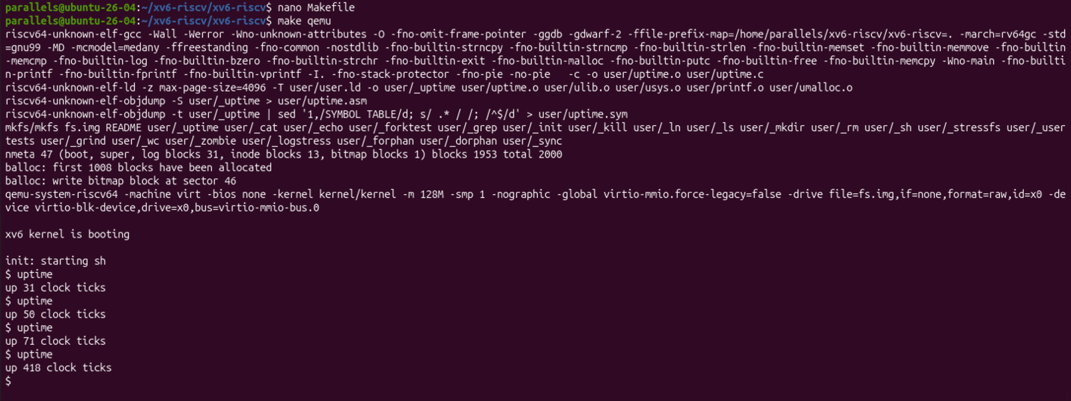

Task 2. (10 pts) Implement a time1 command that reports elapsed time.
Your code time1.c should be in the user directory in the pa1-syscalls branch of your xv6 repo. Remember to add your new command to UPROGS in Makefile.
Show results from running your time1 command.
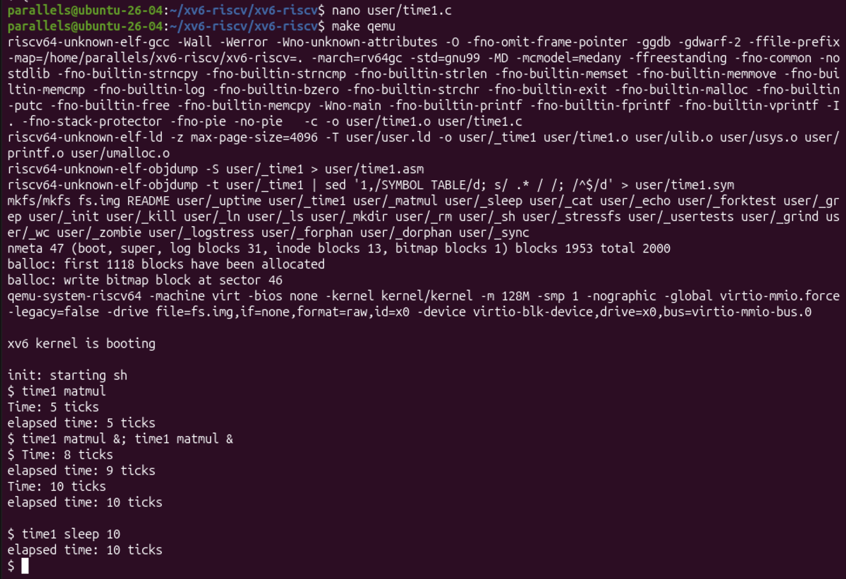

Task 3. (10 pts) Keep track of how much cputime a process has used.
Describe what files you changed and how you changed them. Explain the purpose of each change. Be sure to do git add and git commit as needed and push your changes to your online repo.
In kernel/proc.h, uint cputime was added to struct proc to count timer ticks a process has used. In kernel/proc.c, in allocproc() this is ilitallized to 0 via p->cputtime = 0 so that every new process starts with a 0 count. In kernel/trap.c the counter is incremented where a timer interrupt causes a process to yield, this was in usertrap() when when which_dev ==2 and kerneltrap() with the previous condition and myproc() != 0.

Task 4. (10 pts) Implement a wait2() system call that waits for a child to exit and returns the child’s status and rusage.
List the files you changed and explain the purpose of each change. Be sure to do git add and git commit as needed and push your changes to your online repo.
In kernel/pstat.h the rusage struc was defined and was added to user/user.h this way CPU time is being held and the user programs can call wait2. In user/usys.pl the entry for wait2 was added to generate the assembly stub. In kernel/syscall.h the call was given a numember (23). In kernel/syscall.c it was added to the dispatch table so it is routed to the right handler. In kernel/sysproc.c, sys_wait2() readed the two pointers and passes it to kwait2(), which the rpotoype was added to kernel/defs.h so it is visible outside of proc.c. In kernel/proc.c pstat.h was included and added kwait2() which copies the exited child’s cputime to the parent’s memory.

Task 5. (10 pts) Implement a time command that runs the command given to it as an argument and outputs elapsed time, CPU time, and %CPU used.
Your time.c code should be in the user directory in the pa1-syscalls branch of your xv6 repo. Remember to add your new command to UPROGS in Makefile.
Show results from running your time command.
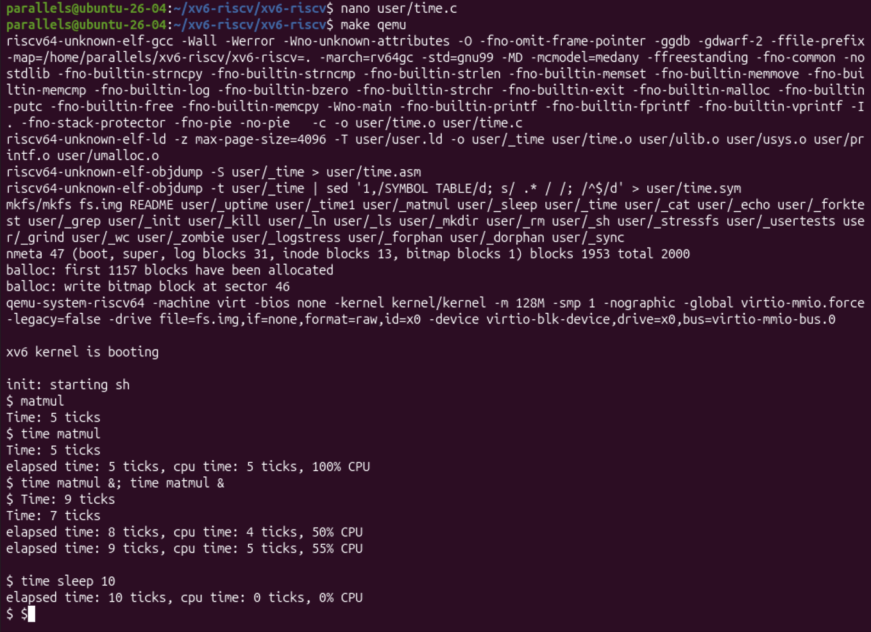

Task 6. (5 pts) Summarize what you learned from doing this assignment. Describe any difficulties you faced and if/how you overcame them.

I learned how a system call goes from a user program into the kernel, and how fork)(. Exec(), and wait2() work together to time a program. That timer interrupt is the natural place to count CPU time. The main difficulties I had were getting the GitHub set up and setting up a SSH key, a couple of compile errors where I had missed a brace, comma, semicolon, or mistyped a variable name. For that I made use of Claude and helping me grasp concepts.

Extra Credit (5 points). Discuss limitations of our time command. (Hint: For one limitation, consider what would happen if the command that is being timed forks child processes).

